HTML/CSS3

Exercises

Version: 1.0.0

Copyright

© Copyright 2021 Capgemini Educational Services B.V.

No part of this publication may be reproduced and/or published by print, photo-print, microfilm, tape recording, electronically or by other means, or stored in a retrieval system, without prior written permission from Capgemini Educational Services B.V.

Table of Contents

1. Final Exercise: Case assignment 4

1.1. Case description 4

1.2. Final assigment 4

1. Final Exercise: Case assignment
   1. Case description

Read the case description as provided. The following web page shows a listing of Set reviews

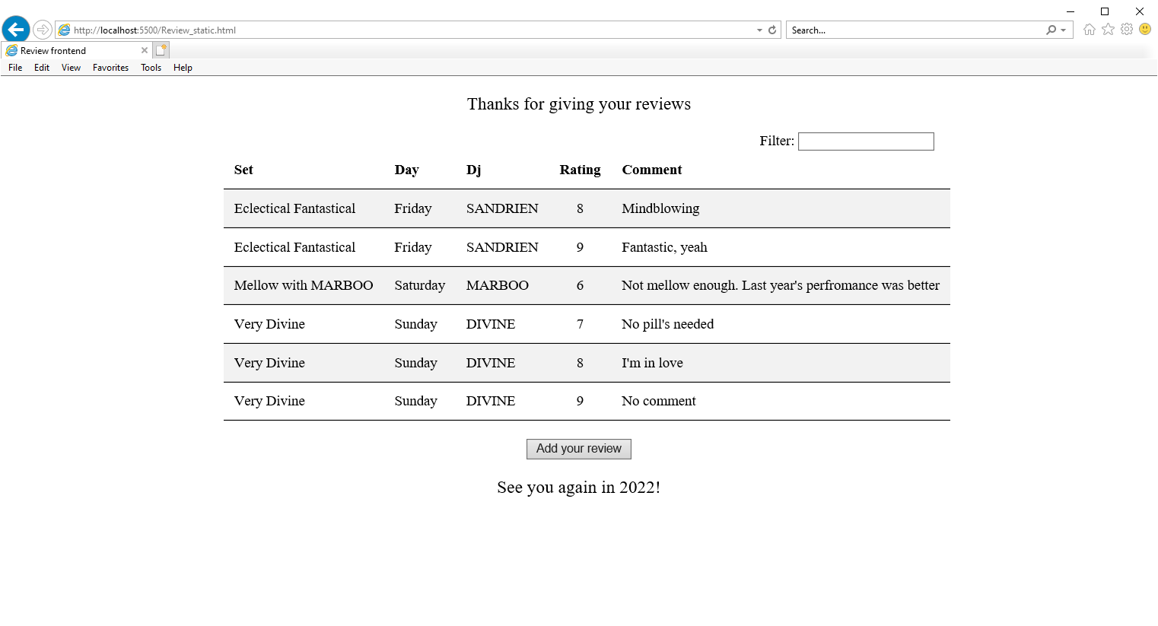

* 1. Final assignment

Create a web page that looks like the provided web page. Try to make it look as close as possible. **The filter and button do not have to be functioning.**

You can use an embedded stylesheet or an external stylesheet.

After completion, share your file(s) with your trainer.

The web page should have:

* Different color for odd and even rows.
* Centered in a way that changing the window size will leave the page centered.

You can use Visual Studio Code to edit the HTML (and CSS) file and open the HTML file in your browser to see the result. After , refresh the page in the browser to see your updates.

You can also use <https://jsfiddle.net/>

(edit your HTML and CSS in the appropriate sections and push ‘run’ in the left upper corner.)

Capgemini Academy's professionals offer what people in IT need. Our professionals have a keen eye for motivation, talent and are aware of specific contexts and circumstances. They move people to move. Programmes and courses that originate from daily experience of our both didactical and substantively strong trainers, light a fire within the individual IT professionals. Real life stories of our professionals’ experience that tell how to solve problems and work with the people around it, do the rest.

An organization, like ours, helps people and their organizations day by day to get the best out of themselves and each other. We prepare them to defy tomorrow's challenges. We stimulate learning and curiosity. In order for individual IT professionals and their employers, to build better, longer and more intensive relationships. For mutual benefit.

Capgemini Academy. We transform IT-professionals.



[academy.capgemini.nl](http://academy.capgemini.nl/)